QUALIFICATIONS
- Filipinas, 18 to 26 years old
- At least a high school graduate and of good moral standing
- With outstanding looks and personality
- Never been married, single, never given birth
- At least 5 feet and 4 inches in height
- With above-average communication skills, and knowledge on and concern for the environment

LIST OF REQUIREMENTS:
- COMPLETELY FILLED UP AND SIGNED APPLICATION FORM (must be in word document format and for immediate completion)
- Clear image or scanned copy of BIRTH CERTIFICATE
- Clear image or scanned copy HIGH SCHOOL or COLLEGE DIPLOMA
- LATEST DIGITAL PHOTOS, in high-resolution (samples below)
- 1 minute video introducing yourself and why you should be the next Miss Philippines Earth
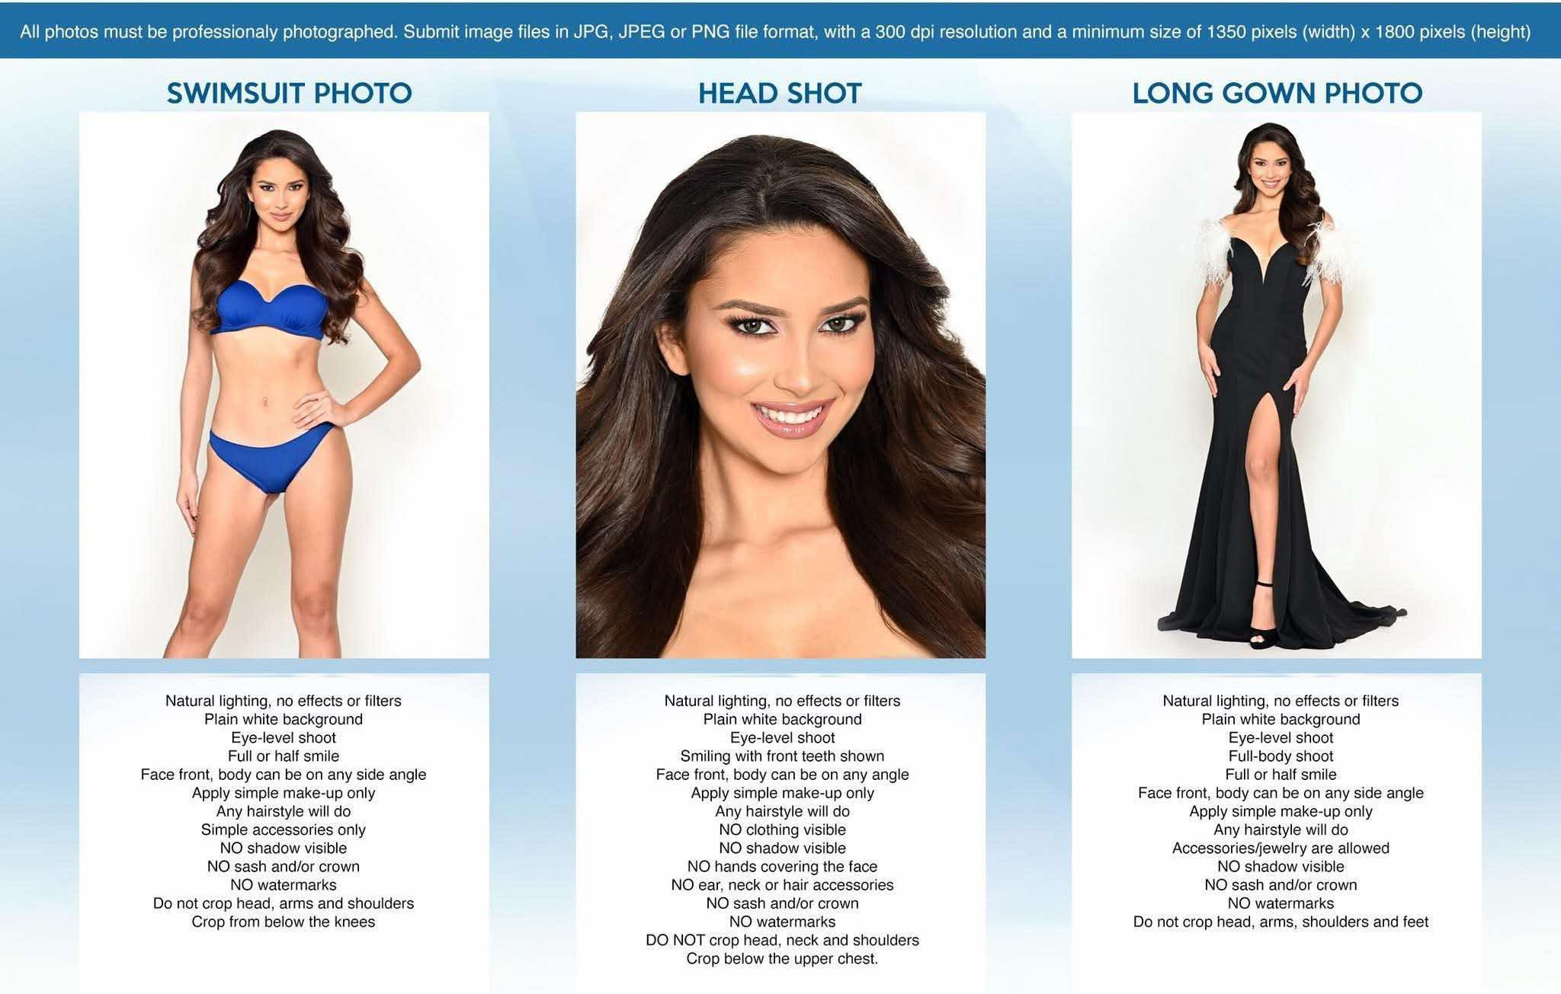
Upon completion, please send, with other requirements listed above, to: secretariat.missphilippines@gmail.com with email subject MPE2026 (your city/municipality)

Municipality or City (to be represented)
Complete Name (First, Middle, Last)
Official name to be used in the pageant
Birthday (MM/DD/YY)
Current Age
Height (in feet and inches)
Weight (in pounds)
Bust /Waist /Hips (in inches)
Shoe size (click HERE to for shoe size conversion)
Dress Size
Citizenship
Complete Address with Zip Code
Primary Mobile Number
Secondary Mobile Number
Landline Number
Email Address
Social media accounts
Educational attainment, course, current level/year
Name of School, College or University:
If working, Position and Company Name
Languages/Dialects Spoken
Countries visited / year(s)
Hobbies
Favorite Books and Authors
Favorite Movies and Actors
Sports or other special interests
Are you joining the talent competition? (YES/NO) :
If yes, please describe your performance
(pyrotechniques are not allowed)

Awards / Citations /Achievements (non-pageant)
Are you under any contract? (YES/NO)
If yes, please indicate with whom, nature of contract and inclusive dates :
Have you participated in any beauty contest? (YES/NO)
If yes, please enumerate following the format pageant, year, placement/award (one line per pageant)
Have you been married? (YES/NO)
Have you given birth? (YES/NO)
Have you committed any criminal/illegal offense?
If yes, please give details
Have you engaged in the following work/occupation:
Model/hostess/GRO in establishments generally known
or reputed to be "girlie" joints? (YES/NO)

PROFILE QUESTIONS

IMPORTANT:

Please be reminded that the delegates are judged and scored from day one of the competition.

Kindly type your answers in english.

Please submit form in word.doc format for convenient uploading to website and social media. Do not convert to pdf. Do not send a scanned copy

All answers will be subject for review and editing into a simplified form suitable for uploading to the miss philippnes earth official web and social sites.

Place or type your answers below each question. Do not use all caps

Please note that your answers will be read by our voice over host during the upcoming virtual and on-ground activities – minimum of 3-5 sentences only.

Please write your answer in “THIRD PERSON”

Any special facts about your family?
(Please write your answer in third person. Example: “Some special facts about her family are….. etc.”)
Describe your childhood/growing up years (8-13 years old)
(Please write your answer in third person. Example: “Her childhood was a very emotional experience….. etc.”)
What is your most memorable moment
(Please write your answer in third person. Example: “Her most memorable experience was….. etc.”)
What is the most unusual thing you've ever done?
(Please write your answer in third person. Example: “The most unusual thing she has ever done was….. etc.”)
What is your ambition in life?
Why do you want to be Miss Philippines Earth 2026?
What is your environmental advocacy and why did you choose this?
What tip can you share to promote eco-tourism in your City/Municipality/Province?

FIGURE AND FORM
What do you do to keep your body fit?
How do you keep yourself healthy?
Do you play any sports?
What are your hobbies?

BEAUTY
What is your beauty regimen?
What is your outlook on beauty?

POISE
What lessons did you learn from your childhood / growing years?
Can you share a personal experience that you feel helped shape you as a person?

PERSONAL
What are your likes and dislikes?
What do you envision your country to be like in the future?
What is your message to your countrymen and the government regarding on our present environment?
Do you have a plan or action to address these issues?
How do you see yourself after this competition?

I certify to the validity and accuracy of the information I have provided in this application form. I hereby understand and agree that any false / misleading / inadequate information provided by me in this application form or omission of important details in this form is a ground for my disqualification before and during the contest or dethronement for winners.

I authorize Carousel Productions, Inc. to use any of the information above for my promotion in events, television, radio, print and for digital content, process and transfer the data I have provided in this form for the purpose of my participation in the Miss Philippines Earth. I also authorize Carousel Productions, Inc. to transfer this data amongst themselves as necessary for the purpose of administering and managing my participation in Miss Philippines Earth, and Carousel Productions, Inc. may also transfer this data to any third parties assisting them in the administration and management of Miss Philippines Earth. I authorize them to receive, possess, use, retain and transfer the Data, in electronic or other form, for these purposes. Furthermore, I understand that I may, at any time, review the data, require any necessary changes to the Data or withdraw my consent in writing by contacting Carousel Productions, Inc. Lastly, I understand that withdrawing my consent may affect my ability to participate in Miss Philippines Earth.

Applicant’s Signature Over Printed Name |  | Date Signed

